What is Joint Accreditation?

The UPMC Center for Continuing Education in the Health Sciences (CCEHS) is accredited by the Joint Accreditation for Interprofessional Education. To be eligible for Joint Accreditation, an organization must demonstrate the structure and processes to plan and present IPCE for at least 25% of all educational activities. IPCE means that the activity is designed by multiple professions for an interprofessional audience and addresses the professional practice gaps of the health care team.

Note: If you offer multiple types of credit, your course is considered Interprofessional Continuing Education (IPCE).

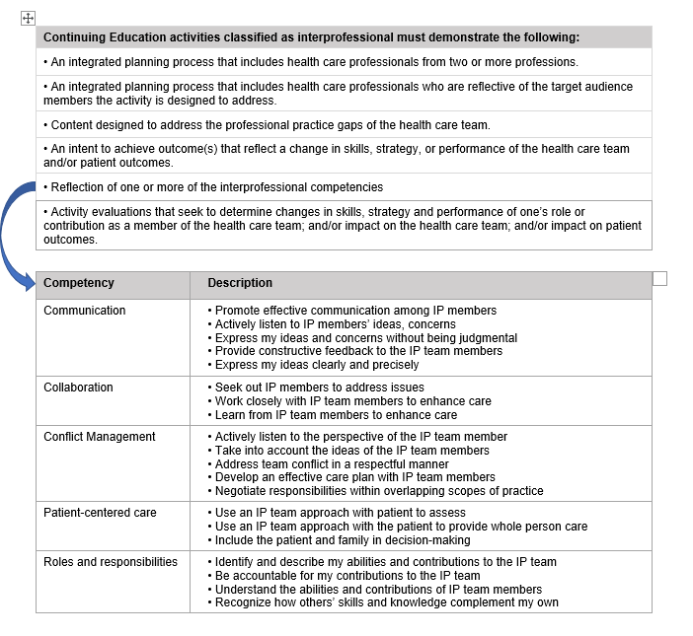
As outlined below, there are specific characteristics of IPCE activities beyond traditional CE activities.

