The Pelvic Pain Symposium
Presented by UPMC Magee’s Women’s Hospital in association with UPMC Dept of Obstetrics and Gynecology, Dept of Urogynecology and Reconstructive Pelvic Surgery, Department of Anesthesiology and Perioperative Medicine, Division of Chronic Pain & UPMC Rehabilitation Institute
Magee Women’s Hospital Auditorium
Friday April 17th, 2026, 7:15am -3:15pm
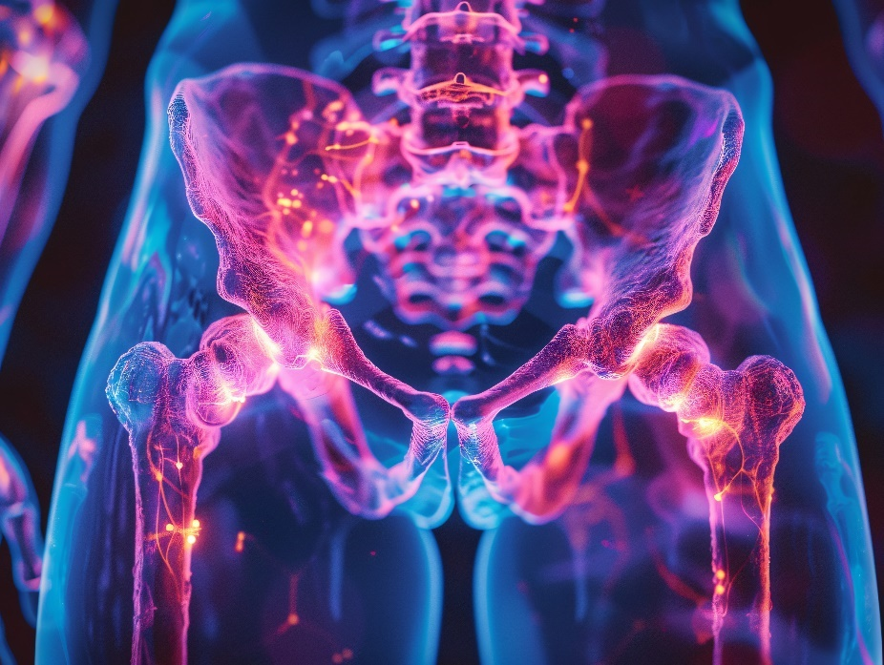
The pelvis is a complex region with multiple potential sources of pain. This conference is a collaborative effort presenting leading experts in their respective fields including OB/Gyn, Urogynecology, Anesthesiology pain management, GI, Behavioral health, Vascular, Orthopedics and Physical Therapy to educate on the multidiscipline approach required to offer patients superior care for a challenging array of etiologies. There will be 20-minute presentations followed by panel discussions for an interactive learning experience.
Course directors: Joanna Hersick PT, Dr. Nicole Donellan MD, Dr. Jocelyn Fitzgerald MD, Dr. Danielle Zheng MD.
Schedule of events.
7:00 -8:00 am Registration, breakfast, Vendor fair
8:00am Introduction – Pelvic pain differential Diagnoses – Nicole Donellan MD
Gynecological Pelvic pain
8:20 am Allison Zeccola, MD.– Endometriosis diagnosis surgical management
8:40 am Sara Allen, MD. – Endometriosis medical management
Bladder and bowel pelvic pain
9:00 am Sun Jung Oh, MD. - GI sources pelvic pain / GI role in endometriosis
9:20am Jocelyn Fitzgerald, MD. – Female bladder pain syndrome
9:40 am Gynecology/bladder/bowel Q& A panel discussion (Dr. Zeccola, Dr. Donnellan, Dr. Allen, Dr Fitzgerald and Dr. Oh)
10:00 am Break
Pain Management
10:20 am Elizabeth Leimer. MD – Medical management of pelvic pain / pain science
10:40 am Danielle Zheng- procedural management of pelvic pain
11:00 am Sue Jarquin Behavioral health Considerations in pelvic pain mgt
11:20 Q & A panel on pain management (Dr. Leimer, Dr. Zheng, Dr, Jarquin)
11:40 am Lunch / Vendors
Musculoskeletal pelvic pain
12:40 pm Joanna Hersick, PT. – Pelvic Floor Physical therapy- What do we do?
1:00 pm Noelle Guthrie, MD.- Orthopedic considerations in pelvic pain
1:20pm Shannon DiPietro, DPT.- Relationship of obturator Internus and hip dysfunction in pelvic pain
1:40 pm PT/Ortho panel
Genetic and Vascular Specialties
2:00pm Mylynda Massart, MD.- Ehlers Danlos Syndrome/ hypermobility and pelvic pain.
2:20 pm Natalie Sridahan, MD. Vascular sources and interventions for pelvic pain.
2:40 pm Specialty panel
3:00 Closing remarks, raffle prizes. Completion of course survey so we can strive to improve with future events. Vendors will be available until 4pm.

Please ensure you sign in and pick up your name tag that will also serve as raffle ticket for prizes donated by our vendors, that will be announced at the end of the day.
Location: Magee Women’s Hospital Auditorium is located at Zero Floor Magee’s Women Hospital, 300 Halket Street, Pittsburgh, PA 15213.

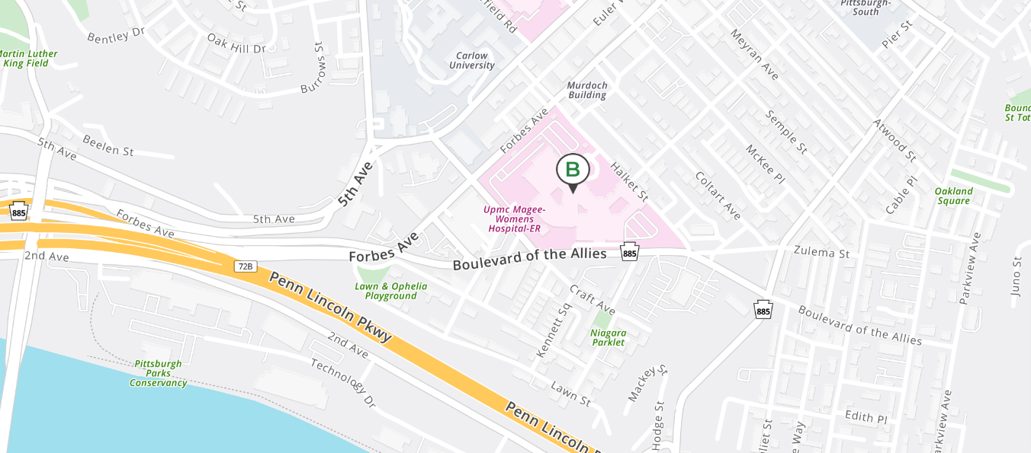
Paid Parking for the event will be available at lower-level parking lot of Magee Women’s Hospital.
You will enter the hospital through the parking garage or the main the entrance and proceed to Zero level to auditorium
Registration will be on a first come first served basis until capacity is reached. When full you can request to be added to waiting list at the email listed below and will be contacted if any cancellations arise.
To register please visit: www.pelvicpainsymposium.com
Approved for 8 CEU’s for MD, DO, PA, NP, Nursing, Behavioral health, PT and OT
Cost: $25
For student Scholarship please reach out to the email listed below.
Any questions regarding event can be directed to hersickj@upmc.edu.

