UPMC Inaugural Center for Cardiovascular Disease Prevention Symposium
September 26, 2026
8:00am-2:30pm
Innovating Prevention- From Precision Science to Real-World Impact
_________________________________________________________________
University of Pittbsurgh
Center for Continuing Education in the Health Sciences
UPMC Heart and Vascular Institute

Welcome and Introduction

This inaugural symposium highlights a comprehensive and multidisciplinary approach to cardiovascular disease (CVD) prevention across the lifespan. The program integrates precision science, clinical implementation, community engagement, and innovation to address major drivers of cardiovascular morbidity and mortality. We will explore prevention strategies in atherosclerosis, arrhythmias and sudden cardiac death, heart failure and cardiomyopathy, social determinants of health, women’s cardiovascular health, and cardio-oncology.

Learning Objectives:
- Apply contemporary evidence-based prevention strategies
- Implement multidisciplinary and lifespan-based prevention strategies to reduce the risk of first cardiovascular events and prevent disease progression or recurrence in diverse patient populations.
- Incorporate social determinants of health, community partnerships, and population health strategies into cardiovascular prevention programs to improve health equity, access to care, and long-term outcomes.
- Recognize and address sex-specific, pregnancy-related, genetic, and treatment-associated cardiovascular risks, including prevention strategies in women’s cardiovascular health, inherited cardiac conditions, and cardio-oncology populations.
- Translate scientific discovery and innovation into clinical and community practice by identifying barriers, facilitators, and implementation strategies that enable sustainable and scalable cardiovascular prevention programs.
- Integrate precision medicine approaches to enhance cardiovascular risk stratification and early disease detection.
- Evaluate and incorporate emerging prevention technologies into cardiovascular prevention strategies.

Continuing Education Credits:

In support of improving patient care, the University of Pittsburgh is jointly accredited by the Accreditation Council for Continuing Medical Education (ACCME), the Accreditation Council for Pharmacy Education (ACPE), and the American Nurses Credentialing Center (ANCC), to provide continuing education for the healthcare team.
Physician (CME)
The University of Pittsburgh designates this live activity for a maximum of 4.50 AMA PRA Category 1 Credit[s]™. Physicians should claim only the credit commensurate with the extent of their participation in the activity.

Nursing (CNE)
The maximum number of hours awarded for this Continuing Nursing Education activity is 4.50 contact hours.

Pharmacy (CPE)
This knowledge-based activity provides 4.50 contact hours of continuing pharmacy education credit.

Physician Assistant (AAPA)
The University of Pittsburgh has been authorized by the American Academy of PAs (AAPA) to award AAPA Category 1 CME credit for activities planned in accordance with AAPA CME Criteria. This activity is designated for 4.50 AAPA Category 1 CME credits. PAs should only claim credit commensurate with the extent of their participation.

Other Healthcare Professionals: Other health care professionals will receive a certificate of attendance confirming the number of contact hours commensurate with the extent of participation in this activity.

Parking

Parking validation stickers will be provided upon check in for the Center Ave (Medical Center) Garage and the Aiken Garage.

Visit the University of Pittsburgh School of Medicine Website for more information on the Center

Grant Sponsorships
None

Exhibit Sponsorships
Alnylam Pharmaceuticals
Amgen Inc.
Arrowhead Pharmaceuticals
AstraZeneca PLC
Boehringer Ingelheim GmbH
Heart Flow Inc.
Ionis Pharmaceuticals Inc.
Merck & Co., Inc.
Novartis AG
Novo Nordisk A/S
Pfizer Inc.
Regeneron Pharmaceuticals, Inc.

Program Agenda
7:30am-8:00am Hall of UPMC Herberman Center
Registration, Breakfast
8:00am-8:10am Main Ballroom/202ABC
Welcome & Center Vision
Samir Saba, MD (Lead Organizer)
Anantha Shekhar, MD
*CME credits offered
8:10am-8:55am: KEYNOTE Main Ballroom/202ABC
Past, Present & Future of Cardiovascular Disease Prevention: My Personal Journey
Christie Ballantyne, MD
*CME credits offered
8:55-9:35am Main Ballroom/202ABC
Preventing the First Event: Atherosclerosis
Marcio Bittencourt, MD
Babak Razani, MD
Anum Saeed, MD (Lead Organizer)
Moderator: Prem Soman, MD (Event Champion)
Panel: Indu Poornima, MD, Timothy Anderson, MD, Marcio Bittencourt, MD Babak Razani, MD,
Anum Saeed, MD

*CME credits offered
9:35am-10:10am Main Ballroom/202ABC
Beating Sudden Death: Arrhythmias & SCD
Sandeep Jain, MD (Event Champion)
Tanmay Gokhale, MD (Event Champion)
Aditya Bhonsale, MD
Aditi Naniwadekar, MD
*CME credits offered
10:10am-10:25am: Main Ballroom/202ABC
Break: Participants are welcome to network while enjoying some coffee and light snacks.
*Non-CME
10:25am-11:05am Main Ballroom/202ABC Catching Heart Failure Before It Starts
Gavin Hickey, MD (Event Champion)
Manling Zhang, MD (Event Champion)
Harriette Van Spall, MD (recorded presentation)
*CME credits offered
11:05am-11:40am Main Ballroom/202ABC The Hidden Half: Women’s Cardiovascular Health
Agnes Koczo, MD (Event Champion)
Malamo Countouris, MD (Event Champion)
Anisha Reddy, MD
Henrietta Afari, MD
Panel: Kim Bollinger, CRNP, Anisha Reddy, MD, Henrietta Afari, MD
*CME credits offered

11:40am-12:15am Main Ballroom/202ABC
Beyond the Heart: Cardio-Systematic Interactions
Oscar Lopez, MD
Stephen Chan, MD, PhD
Moderator: Daniel Sinden, MD (Event Champion)
Panel: Evan Ray, MD, PhD, Erin Kershaw, MD, Stephen Chan, MD, PhD, Oscar Lopez, MD
*CME credits offered

12:15pm-12:45pm Main Ballroom/202ABC
Prevention Where People Live
Jared Magnani, MD, MSc(Event Champion)
Moderator: Alison Culyba, MD, PhD, MPH (Event Champion)
Panel: Tamara Dubowitz, SM, MSc, ScD, Noble Maseru, PhD, MPH, Kyaien Conner, PhD, LSW, MPH
*Non-CME

12:45pm-1:15pm Main Ballroom/202ABC
Working Lunch break
Industry booth networking
*Non-CME

1:15pm-1:55pm Main Ballroom/202ABC
Innovation Spotlight: Platforms That Bend the Curve
Hooman H Rashidi, MD, MS
Moderator: Suresh Mulukutla, MD (Event Champion)
Panel: Shiv Rao, MD, Hooman H Rashidi, MD, MS
*Non-CME

1:55pm-2:00pm Main Ballroom/202ABC
Pilot Project Announcement
Samir Saba, MD (Event Leadership)
*Non-CME

2:00pm-2:25pm Main Ballroom/202ABC
Building the Future: Cardiovascular Prevention in 2026
*Non-CME

2:25pm-2:30pm Main Ballroom/202ABC
Closing Vision & Call to Action
*Non-CME

Thank You!

We extend our sincere gratitude to our donors for their unwavering support and generosity.

A special thank you to our planning committee for their commitment to providing the most informed and relevant information to this educational event.
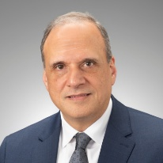
Samir Saba, MD, FACC, FHRS
Professor of Medicine and Translational Science
Chief, Division of Cardiology, Department of Medicine
Harry S. Tack Chair, University of Pittsburgh School of Medicine
Co-Director, UPMC Heart and Vascular Institute

Kathryn Berlacher, MD, MS, FACC
Associate Professor of Medicine, University of Pittsburgh School of Medicine
Clinical and Strategic Director of Cardiology, UPMC Heart and Vascular Institute
Chair of Medicine, UPMC Magee-Women’s Hospital
Director, UPMC Magee-Women’s Heart Program
Associate Chief of Education, Cardiology Division

Anum Saeed, MD
Assistant Professor
UPMC Heart and Vascular Institute
University of Pittsburgh School of Medicine

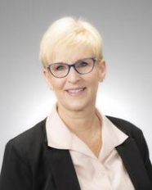
Lisa Henry, CRNP, DNP
Director, Heart and Vascular Services
UPMC Heart and Vascular Institute

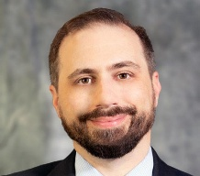
Philip Empey, PharmD, PhD
Associate Professor, Department of Pharmacy and Therapeutics
Director, Center for Clinical Pharmaceutical Sciences
Associate Director for Pharmacogenomics, Pitt/UPMC Institute for Precision Medicine


Sarah Reiland, PA-C
Physician Assistant, UPMC Magee-Women’s Heart Program

Champions of this event
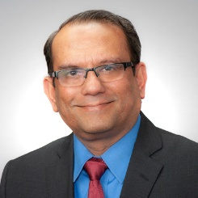
Prem Soman, MD, PhD, FACC, FRCP
Professor of Medicine
Richard S Caligiuri Endowed Chair in Amyloidosis and Heart Failure
Associate Chief of Cardiology, Faculty Development
Director, Cardiac Amyloidosis Center
Director, Nuclear Cardiology and Cardiac Imaging Fellowship

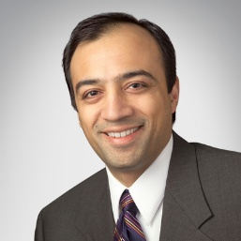
Sandeep Jain, MD
Professor of Medicine

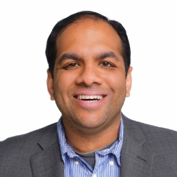
Tanmay Gokhale, MD, PhD
Assistant Professor of Medicine

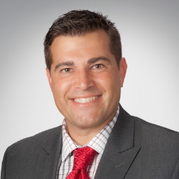
Gavin Hickey, MD
Assistant Professor of Medicine
Medical Director, VAD and Transplant Program, UPMC Heart and Vascular Institute

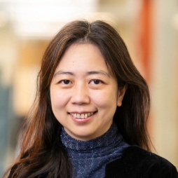
Manling Zhang, MD, MS
Assistant Professor of Medicine

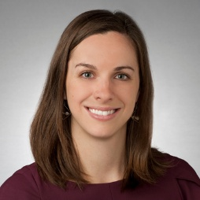
Agnes Koczo, MD
Assistant Professor of Medicine


Malamo Countouris, MD, MS
Assistant Professor of Medicine
Director, Clinical Scientist Track, Internal Medicine Residency Program

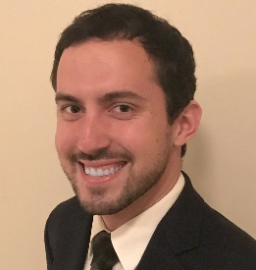
Daniel Sinden, MD, PhD
Cardiologist, UPMC

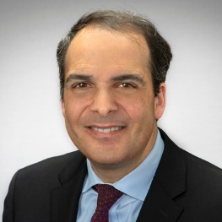
Jared Magani, MD, MSc
Professor of Medicine

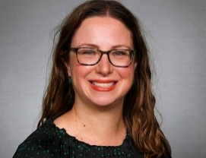
Alison Culyba, MD, PhD, MPH
Division Director, Adolescent and Young Adult Medicine
Associate Professor of Pediatrics, Public Health and Clinical and Translational Science
Director, Career Educational and Enhancement for health Care Research Diversity (CEED) Program

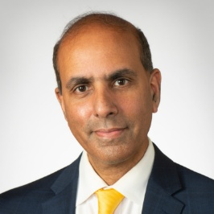
Suresh Mulukutla, MD
Associate Professor of Medicine
Chair of Cardiology, UPMC Passavant
Director of Analytics- Cardiology
Director, HVI Center for Outcomes and Innovation

Guest Speakers:

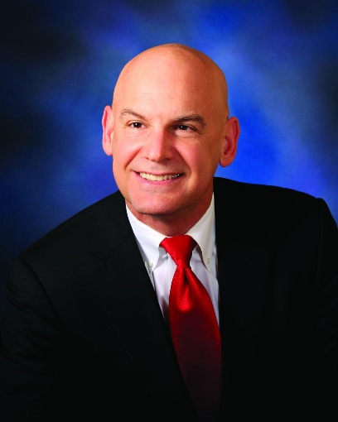
Christie Ballantyne, MD
Section Chief of Cardiology and Cardiovascular Research, BCM
Professor of Medicine, Cardiology and Molecular and Human Genetics
Professor of Molecular Physiology and Biophysics
Director, Maria and Alando J Ballantyne, MD Atherosclerosis Clinical Research Laboratory
Director, Center for Cardiometabolic Disease Prevention
Co-Director, Lipid Metabolism and Atherosclerosis Clinic
J.S. Abercrombie Chair, Atherosclerosis and Lipoprotein Research
Baylor College of Medicine
Keynote Speaker: Inaugural Center for Cardiovascular Disease Prevention Research Symposium - University of Pittsburgh

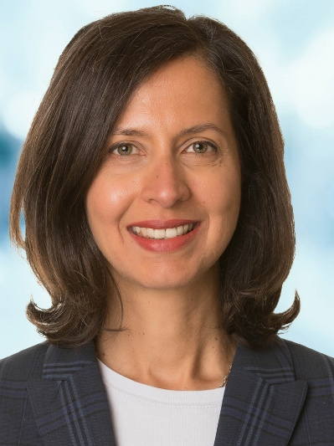
Harriette Van Spall, MD
Associate Professor of Medicine, McMaster University
Director of Implementation Science, Baim Institute for Clinical Research
Cardiologist, Hamilton Health Sciences

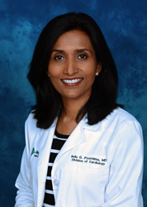
Indu Poornima, MD, MS, FACC
Professor of Medicine, Drexel University College of Medcine
Director, Clinical Cardiology & Imaging
Quality Officer, Cardiovascular Institute
Allegheny Health Network

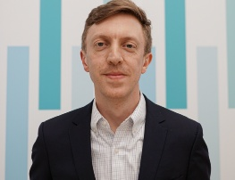
University of Pittsburgh & UPMC Speakers:
Timothy Anderson, MD MAS
Assistant Professor of Medicine
Director, Clinical-Researcher Fellowship

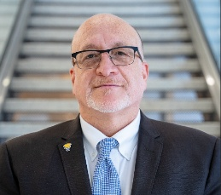
Hooman Rashidid, MD, MS, FCAP
Associate Dean of AI in Medicine, Professor & Endowed Chair of Lombardi- Shinozuka Experimental Pathology Research, University of Pittsburgh School of Medicine
Executive Vice Chair of Computational Pathology & Infomatics Division, UPMC
Executive Director, Computational Pathology & AI Center of Excellence (CPACE)

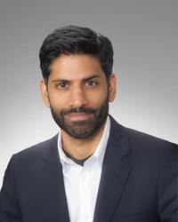
Shiv Rao, MD
Founder & CEO, Abridge
Cardiologist, UPMC

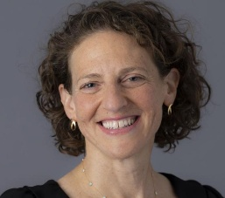
Tamara Dubowitz, SM, MSc, ScD
Chair, Department of Epidemiology, School of Public Health

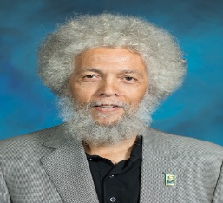
Noble Maseru, PhD, MPH
Professor, Public Health Practice, Schools of Health Sciences
Director, Social Justice, Racial Equity and Faculty Engagement, The Walter Rodney Foundation
Inaugural 2022 recipient of the PA Department of Health Office of Health Equity’s Health Equity Champion Award


Kyaien Conner, PhD, LSW, MPH
Dean, University of Pittsburgh School of Social Work
Professor and Donal M. Henderson Endowed Chair
Director, Center for Rache and Social Problems, School of Social Work
Associate Dean for Justice, Equity, Diversity and Inclusion

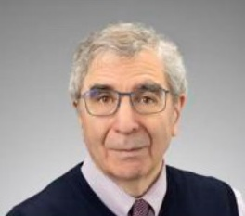
Oscar Lopez, MD, FAAN
Professor of Neurology, Psychiatry and Clinical & Translational Sciences
Chief, Cognitive and Behavior Neurology Division
Levidow, Pittsburgh Foundation Endowed Chair in Alzheimer’s Disease and Related Dementias
Director, Alzheimer’s Disease Research Center

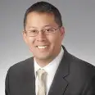
Stephen Chan, MD, PhD, FAHA
Professor of Medicine
Director, Vascular Medicine Institute,
Director, Center for Pulmonary Vascular Biology and Medicine
University of Pittsburgh


Evan Ray, MD, PhD, FASN
Associate Professor of Medicine
Director, UPMC Hypertension Center

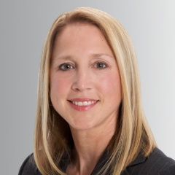
Erin Kershaw, MD
Associate Professor of Medicine
Endowed Chair for Obesity and Diabetes Research

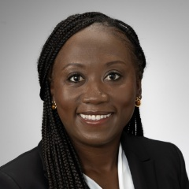
Henrietta Afari, MD
Assistant Professor of Medicine

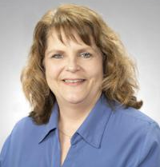
Kim Bollinger, CRNP, MSN
Maternal cardiology


Anisha Reddy, MD
Cardiovascular Fellow

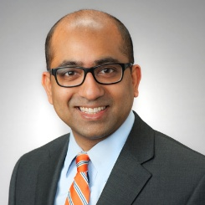
Aditya Bhonsale, MBBS, MD MHS
Assistant Professor of Medicine

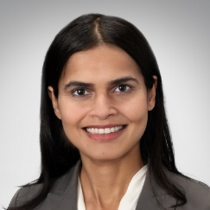
Aditi Naniwadekar, MD
Assistant Professor of Medicine

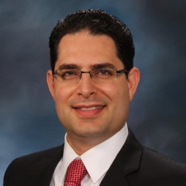
Babak Razani, MD, PhD
Professor of Medicine

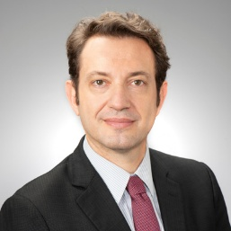
Marcio Bittencourt, MD, PhD, MPH
Associate Professor of Medicine

Disclaimer Statement
The information provided at this CME program represents the views and opinions of the individual presenters and does not constitute the opinion or endorsement of or promotion by, the UPMC Center for Continuing Education in the Health Sciences, UPMC/ University of Pittsburgh Medical Center or Affiliates and University of Pittsburgh School of Medicine. Reasonable efforts have been taken intending for educational subject matter to be presented in a balanced, unbiased fashion and in compliance with regulatory requirements. However, each program attendee must always use his/her own personal and professional judgement when considering further application of this information, particularly as it may relate to patient diagnosis or treatment decisions including, without limitation, FDA-approved uses and any off-label uses.

Disclosures
All individuals in a position to control the content of this educational activity have disclosed all financial relationships with any companies whose primary business is producing, marketing, selling, reselling, or distributing healthcare products used by or on patients.

All the relevant financial relationships for the individuals listed below have been mitigated.

Christie Ballantyne, MD: Consultant: 89Bio, Abbott Diagnostics, Amgen, Arrowhead, Astra Zeneca, Denka Seiken, Esperion, Genentech, HeartFlow, Ionis, Eli Lilly, Merck, NewAmsterdam, Novartis, Novo Nordisk, Roche Diagnostic; Grant/ Research Support: Abbott Diagnostic, Akcea, Amgen, Arrowhead, Ionis, Eli Lilly, Merck, New Amsterdam, Novartis, Novo Nordisk, Roche Diagnostic, NIH, AHA, ADA

Marcio Bittencourt MD, PhD, MPH: Grant/ Research Support: Cleerly

Stephen Chan, MD, PhD, FAHA: Consultant: Merck, Janssen, United Therpeutics; Grant/ Research Support: National Institutes of Health, American Heart Assoc. and WoodNext Foundation; Other: Director, Officer, and Shareholder in Synhale Therapeutics and Amlysion Therapeutics

Tanmay Gokhale, MD, PhD: Clinical Fellowship Support: Boston Scientific, Medtronic, Abbott

Gavin Hickey, MD: Consultant: Abiomed/J&J

Sandeep Jain, MD: Consultant: Abbott Grant/ Research Support: Boston Scientific, Medtronic, Abbott

Erin Kershaw, MD: Consultant: Nodthera, Sparrow, vTv Therapeutics; Grant/ Research Support: Arrowhead Pharmaceuticals, Eli Lilly

Oscar Lopez, MD, FAAN: Consultant: Genentech; Other: Acumen: DSMB

Indu Poornima, MD, MS, FACC: Grant/ Research Support: Lilly, Amgen, Novartis

Samir Saba, MD, FACC, FHRS: Consultant: Boston Scientific, Medtronic, Abbott, Recor
Grant/ Research Support: Abbott, Boston Scientific

Anum Saeed, MD: Grant/ Research Support: American Heart Association, National Institute of Health

Prem Soman, MD, PhD, FACC, FRCP: Consultant: Pfizer, Bridgbio, Astra Zeneca, Alnylam

Harriette Van Spall, MD: CE Speakers Bureau: Bayer, Medtronic; Consultant: NovoNordisk; Grant/ Research Support: Canadian Institutes of Health Research; Other: Baim, Bayer, CardioVascular Research Foundation, Colorado Prevention Center, NovoNordisk, Pfizer, Medtronic – Clinical Trial Committee

No other members of the planning committee, speakers’, presenters, authors, content reviewers and/or anyone else in a position to control the content of this educational activity have relevant financial relationships with any companies whose primary business is producing, marketing, selling or distributing healthcare products used by or on patients.

For those interested in supporting the research initiatives of the Center for Cardiovascular Disease Prevention Research, please consider donating using the QR code below.


